**“I draw so as not to forget”: Indigenous Memory of the Paraguayan Chaco**

***Julietta Molinas***

**Keywords:** Indigenous, Paraguay, Latin America, climate change, artist.

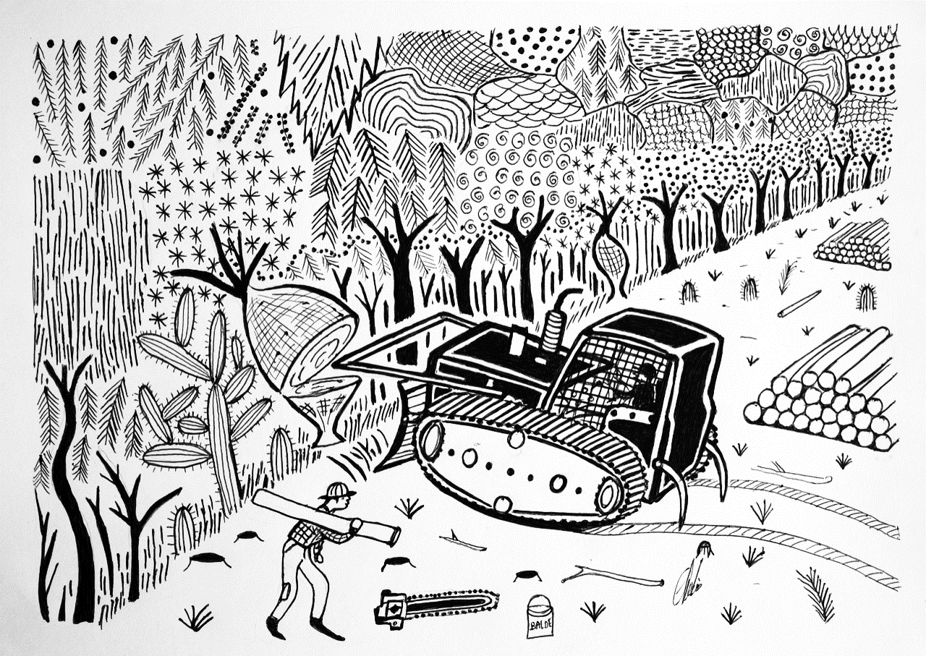

*Bulldozer and chainsaw.* Clemente Juliuz. <https://fundaciontexo.org/muestras/dibujo-para-no-olvidar/>

When something in our surroundings changes, we each perceive and express it in our own way. That personal perception becomes the lens through which we see the world, and for an artist, this lens translates into a deeply personal act of expression: a musician may convey the urgency of caring for the planet through a song, while a writer may imagine dystopian and post-apocalyptic futures, reflections of human indifference towards the environment.

Similarly, visual artists capture in their work the traces that their changing environment leaves on them. For those who are part of indigenous communities, that perception becomes even more intimate and profound, because they live and feel the effects of nature's transformation first-hand. In this regard, I would like to bring up the example of a specific artist who has contributed significantly to indigenous art in Paraguay*. He was Clemente Juliuz (1972-2021), a member of the Nivaclé community of the Paraguayan Chaco, who with just paper and a black pen portrayed the ecosystem that surrounded him.

His early works focused on capturing the beauty of nature in the Chaco region: palo santo trees, quebracho trees, palms and cacti served as a backdrop for the tapirs, armadillos and ostriches that occupied the foreground of the frame. Over time, his distinctive drawings took on a more social tone: he began to portray tractors, chainsaws, weeders... deforestation in the Chaco was becoming increasingly evident[1], making it difficult for him not to include it among his ink-drawn bushes and insects. In the documentary *“Dibujo para no olvidar”* (I draw so as not to forget), made by visual artist Fredi Casco and photographer Fernando Allen, and released earlier this year during an exhibition in Asunción called “The Dream of the Jaguar”, Clemente expressed his concern about the situation: “I’m thinking about deforestation, I’m very worried because the forests are disappearing. There are almost no forests left in our surroundings.”

But he was not the only one expressing himself through this art form in the indigenous communities of the Chaco. In 1998, a drawing competition organised by Swiss anthropologists Verena and Ursula Regehr in the Nivaclé community of Cayin ô Clim gave rise to the *Colectivo Indígena Artes Vivas* (Indigenous Living Arts Collective), made up of self-taught artists from the Nivaclé, Guaraní and Maká peoples. Over the years, the collective grew to include more voices and styles. Around 2010, Clemente joined with his flowers and capybaras drawn in pen, which became his personal artistic trademark. Shortly afterwards, Marco Ortiz and Esteban Klassen arrived, using the same technique but depicting different objects.

Marco Ortiz’s muses were peccaries (*Catagonus wagneri*), which he almost always drew searching for food in the bush. His lines were so fine, in terms of thickness and elegance, that some compared them to filigree. Until his death in 2022, art was his main source of income: “Drawing is my job, it gives me money. If I don’t sell [my] drawings, I have nothing to eat. I don’t work for a Mennonite boss[2], I just draw. It is work I can do at home.” Statements like this are common among indigenous artists from all fields who, although they find valuable opportunities to exhibit their work in artistic collectives, continue to be affected by the precarious situation in their communities and the advance of agribusiness in the area.[3]

On the other hand, Esteban Klassen prefers to evoke shamanic mysticism through his drawings. When Christianity arrived in the Paraguayan Chaco, first with Franciscan and Jesuit missionaries in the 17th century and then with Protestants in the 1920s, shamans were frowned upon and associated with ‘the devil's ways’. But in the indigenous cosmovision, the shaman is a mediator between the spiritual and earthly worlds, someone who can communicate with animals, expel demons and cure illnesses. Through his drawings, Esteban captures the metamorphosis of the shaman into iconic animals of the Chaco fauna, such as the jaguar and the armadillo, thanks to the knowledge inherited from his grandfather.[4]

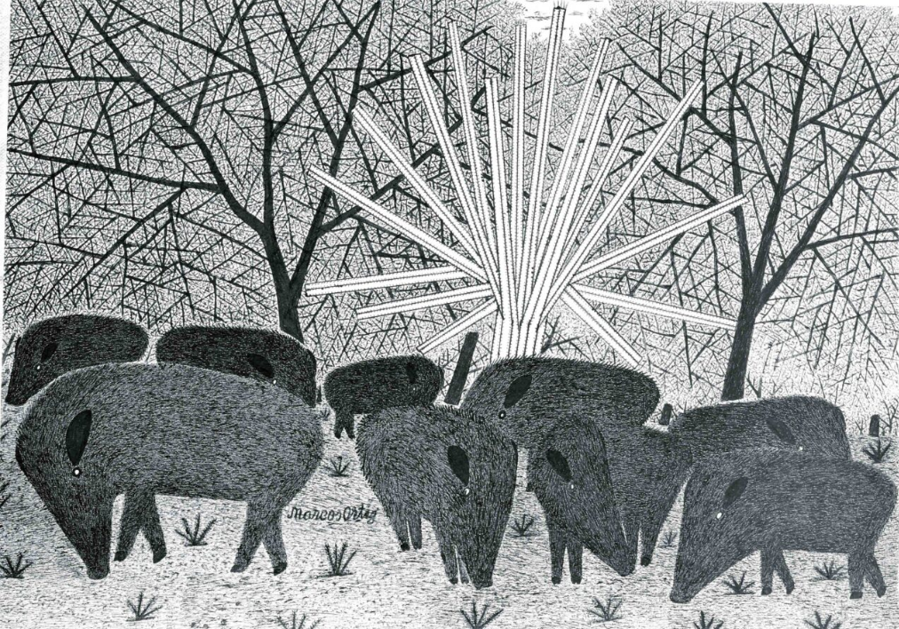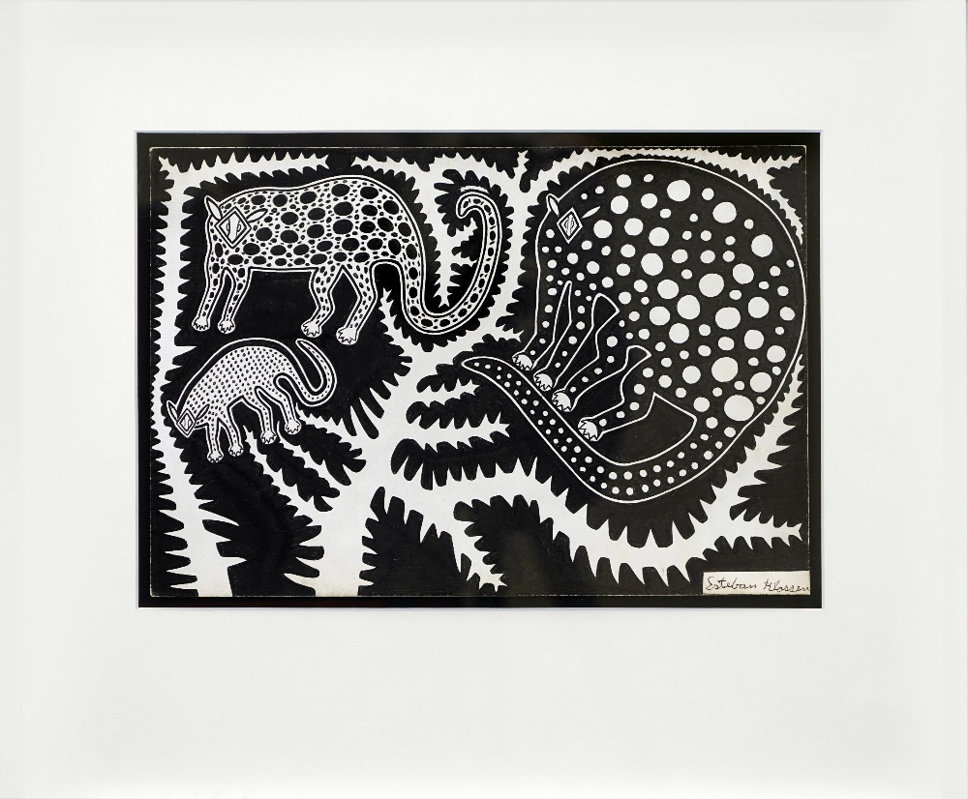

Figure 1. *Marcos Ortiz enjoyed portraying peccaries searching for food in the bush, with lines so fine that they resembled filigree.* Source: SDCELAR.

Figure 2. *Esteban Klassen has chosen to represent shamanic symbolism in his art, which can now be found for sale in online shops for around €1,000.* Source: 1stDibs.

Each stroke of ink on the paper evokes the beauty of the flora and fauna of the Chaco. Yet these same lines also preserve the fragility of their territory, their memory and their culture, which today are threatened by aggressive external pressures. This is how Clemente, Marco, Esteban and other artists in the collective transform this loss into a visual lament, where the tracks of the bulldozer intertwine with the figure of the jaguar and the silhouette of the forest.

The journey of these artworks to international stages proves the power with which they speak. The exhibition *Trees / Nous les Arbres* in 2019 at the Fondation Cartier, for example, included drawings and works by artists from the collective—including the three aforementioned—who depict landscapes, emblematic trees, fauna and flora with a perspective that links everyday life with the changes in their environment.[5]

Nevertheless, this visibility on the international stage does not change the precarious conditions faced by their communities of origin. Many of these artists continue to depend on private collectors or social projects promoted by anthropologists and curators to gain access to important museums and galleries. The history of the collective and the collection created by the Regehrs is an example of how institutional mediation can open doors, but also why those doors need to be permanent and public.

Reading these drawings today is like reading two versions of the same map: one of the changing physical territory and another of a collective memory that resists. From this intersection emerges the urgent need to preserve the land and, with it, the culture of those who inhabit it. That is why it is vital to unite art, heritage and public policy, and Paraguay still has a long way to go in this regard. State programmes are needed to promote collectivisation, institutional purchasing and residencies[6] and ethical marketing networks, so that indigenous artists are not forced to choose between exhibiting their work and surviving.

These drawings show us the great Paraguayan Chaco through the eyes of those who witness the advance of bulldozers and chainsaws. They are strokes that speak of resistance and hope. Each line emphasises that preserving indigenous memory and territory is a right, not an act of charity: it is their communities that have sustained Paraguayan culture and they must decide how to live, create and tell their stories.

*\* A special acknowledgement to my friend Lorena Sforza, who introduced me to the world of indigenous drawing through her own experience working and researching with them in Paraguay and, therefore, gave me the inspiration I needed to write this short article.*

**References**

“Artist Residencies.” Artquest, n.d. <https://artquest.org.uk/how-to-articles/artist-residencies>.

Bindman, Polly, and Elisângela Mendonça. “Bancos de Wall Street Impulsan La Deforestación En Bosque Paraguayo.” Global Witness, December 10, 2024. <https://globalwitness.org/es/campaigns/forests/bancos-de-wall-street-impulsan-la-deforestacion-en-bosque-paraguayo/>.

“Disegni a Inchiostro Paraguaiano Dal Chaco #10 Carta Inchiostro Indigena E. Klassen.” 1stDibs, 2025. <https://www.1stdibs.com/it/arte/disegni-e-acquarelli/disegni-e-acquarelli-animali/esteban-klassen-disegni-a-inchiostro-paraguaiano-dal-chaco-10-carta-inchiostro-indigena-e-klassen/id-a_15883112/>.

Gamarra, Willian. “La Historia de Las Colonias Menonitas En El Chaco.” RCC, April 27, 2022. <https://rcc.com.py/chaco/la-historia-de-las-colonias-menonitas-en-el-chaco/>.

Regehr, Verena, Regehr, Ursula, and Colectivo Indígena Artes Vivas. “Declaración Artística: Colectivo Indígena ‘Artes Vivas.’” Santo Domingo Center of Excellence for Latin American Research (SDCELAR) at the British Museum, March 11, 2022. <https://www.sdcelarbritishmuseum.org/noticias-es/declaracion-artistica-colectivo-indigena-arte-vivo/?lang=es>.

1. The Paraguayan Gran Chaco is facing severe deforestation: Agricultural expansion, driven mainly by multinational corporations, could lead to its disappearance by 2080 if current deforestation rates continue. See Polly Bindman and Elisângela Mendonça, “Bancos de Wall Street Impulsan La Deforestación En Bosque Paraguayo,” Global Witness, December 10, 2024, <https://globalwitness.org/es/campaigns/forests/bancos-de-wall-street-impulsan-la-deforestacion-en-bosque-paraguayo/>.
2. The Mennonites settled in the Paraguayan Chaco in 1927, in colonies such as Menno, Fernheim and Neuland, where they maintain their communal and pacifist lifestyle and are mainly engaged in farming and livestock activities. See Willian Gamarra, “La Historia de Las Colonias Menonitas En El Chaco,” RCC, April 27, 2022, <https://rcc.com.py/chaco/la-historia-de-las-colonias-menonitas-en-el-chaco/>.
3. Verena Regehr, Ursula Regehr, and Colectivo Indígena Artes Vivas, “Declaración Artística: Colectivo Indígena ‘Artes Vivas,’” Santo Domingo Center of Excellence for Latin American Research (SDCELAR) at the British Museum, March 11, 2022, <https://www.sdcelarbritishmuseum.org/noticias-es/declaracion-artistica-colectivo-indigena-arte-vivo/?lang=es>.
4. Ibid.
5. Ibid.
6. Artist residencies are temporary periods of time for an artist to work on a project or develop new ideas. They are time out of [their] usual work to develop new art and ideas. See “Artist Residencies,” Artquest, n.d. <https://artquest.org.uk/how-to-articles/artist-residencies>.